Daniel Meyer

CSE 420-01

Lab 2

Windowing and Drawing Objects

**Part 1:**

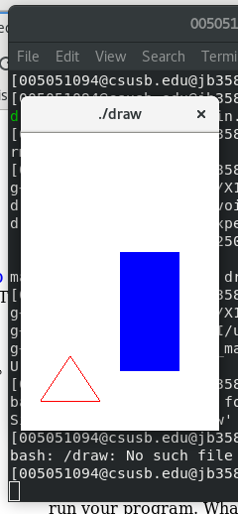

**Above:**

glutInitWindowSize(200, 300); //set window size on screen

glutInitWindowSize(400, 600); //set window size on screen

glutInitWindowSize(300, 200); //set window size on screen

**Part 2:**

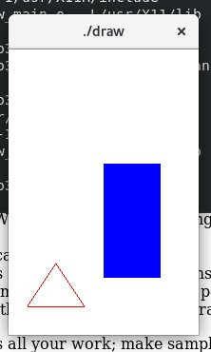

**Above:**

glutInitWindowPosition(300, 350); //set window position on screen

glutInitWindowPosition(500, 350); //set window position on screen

glutInitWindowPosition(300, 550); //set window position on screen

**Part 3:**

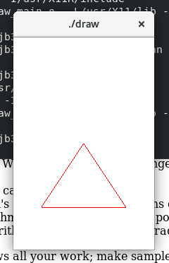

**Above:**

gluOrtho2D(0.0, 250.0, 0.0, 250.0);

**Part 4:**

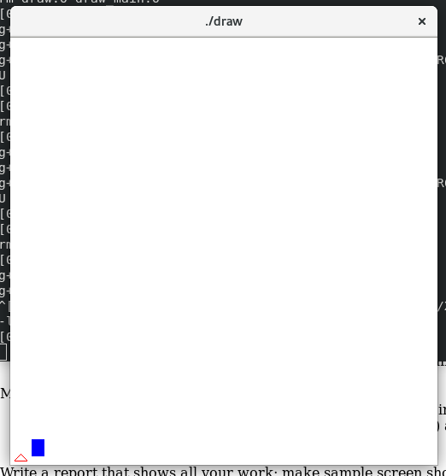

glViewport(0, 0, 50, 50);

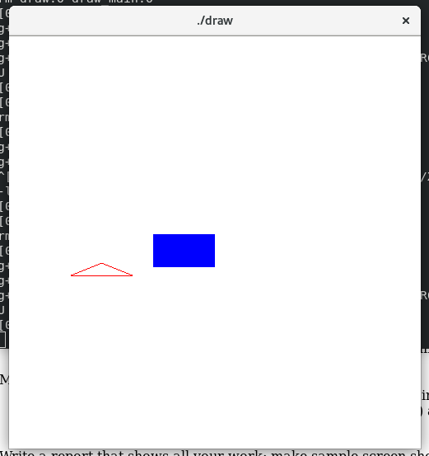

glViewport(150, 200, 250, 100);

**Part 5:**

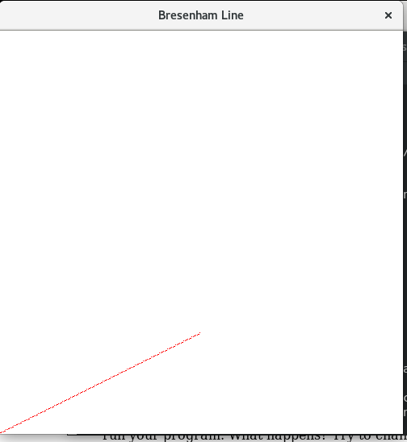

int x0 = 0, y0 = 0, xn = 200, yn = 100, x, y;

Line algorithm with end points (0, 0) and (200, 100)

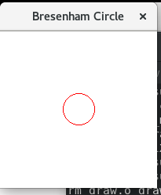

int xCenter = 100, yCenter = 100, r = 20;

Circle algorithm with a circle with radius of 20.

**Summary:**

The lab was intended to learn how to modify the world window’s size and positions within the screen window as well as using glViewport to scale the world window in OpenGL. Furthermore, Bresenham’s line algorithm was used as well as a modified version of it to produce a circle was used. I successfully changed the size and position of the world window multiple times as well as modifying the Viewport. When implementing the Bresenham algorithms, I successfully made a line with the specified end points as well as created a circle with the specified radius. All programs compiled and ran without error and as such feel my submission is worth the full 20 points.

**Submission Note:** Had to remove extra screenshots for Windows Size and Position modifications due to submission file size being too large (1.1 MB).